32.55: a) 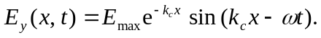
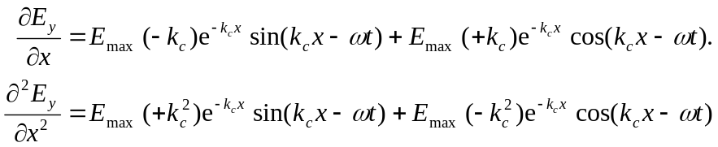
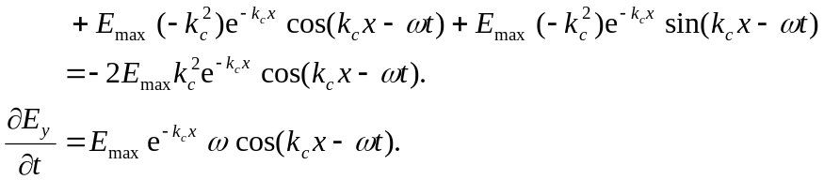
Set 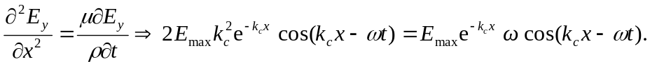This will only be true if 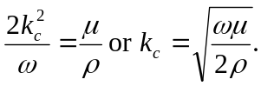
b) The hint basically answers the question.
c) 